Cyber Weather Information Terminal — Complete Project Documentation
This document provides complete technical, architectural, operational, and visual documentation for the Cyber Weather Information Terminal.

1. System Architecture & Key Components
The project uses a decoupled Model-View-Controller (MVC) design pattern to separate network operations, data parsing, rendering logic, and local storage.
+--------------------------+
| WeatherAppGUI | (View / Controller)
+------------+-------------+
|
+----------------------+----------------------+
| | |
v v v
+---------------+ +-------------------+ +----------------------+
| WeatherData | | WeatherService | | SearchHistoryManager |
| (Data Model) | | (Open-Meteo API) | | (Persistence) |
+---------------+ +-------------------+ +----------------------+

Core Components
- WeatherAppGUI (View & Master Controller): Houses the main Swing container, manages event handlers, initiates non-blocking background workers, and hosts custom graphics panels.
- WeatherIconPanel (Java 2D Render Engine): A custom JPanel sub-component that calculates real-time vector transformations (scaling, rotation, translation) to draw procedural weather icons (sun, moon, clouds, rain, lightning, snow).
- GradientPanel (Dynamic Theme Engine): Renders dynamic visual backdrops based on weather condition severity and local daytime/nighttime indicators.
- WeatherService (Network Layer): Executes asynchronous HTTP requests against the Open-Meteo API, resolving geocoding coordinates and current/forecast meteorological metrics.
- WeatherData (Data Model): Immutable data transfer object holding metrics such as temperature, wind speed, humidity, coordinates, WMO weather codes, and 5-day forecast objects.
- SearchHistoryManager (Local Persistence): Manages local search query logs and drop-down state persistence.

2. Automated Weather Code Mapping Engine
The application processes WMO (World Meteorological Organization) Weather Interpretation Codes returned from live API payloads to automatically select visual assets, background themes, and vector animations.
WMO Code Scope | Condition Summary | Dynamic Graphic Render | Background Gradient Theme
0 | Clear Sky | Pulsing Sun / Crescent Moon + Soft Cyan Cloud Accent | Daylight Cyan / Slate Navy (Night)
1, 2 | Mainly Clear / Partly Cloudy | Pulsing Sun + Floating Translucent Clouds | Azure Blue / Slate Navy
3, 45, 48 | Overcast / Fog | Solid Grey Layered Cloud Mass | Muted Grey Slate
51 – 82 | Drizzle / Light & Heavy Rain | Overcast Cloud Mass + Falling Blue Raindrops Loop | Dark Storm Slate / Navy
71 – 77 | Falling Snow | Overcast Cloud Mass + Diagonally Drifting Snow Particles | Cool Ice Blue / Steel Slate
95 – 99 | Thunderstorm | Dark Cloud Mass + Animated Flashing Lightning Bolts | Deep Midnight Slate

3. Class Specifications & Formulas

3.1 WeatherAppGUI
Main window frame (javax.swing.JFrame).
- public WeatherAppGUI(): Initializes system Look & Feel, constructs components, activates the continuous 30 FPS animation loop, and fetches default telemetry (Nairobi).
- private void startGlobalAnimationLoop(): Instantiates a 33ms javax.swing.Timer executing repaint() to update procedural vectors (pulsing sun, falling rain/snow, drifting clouds) without blocking the Event Dispatch Thread (EDT).
- private void fetchWeatherDataAsync(String query): Spawns a SwingWorker<WeatherData, Void> to execute external HTTP network requests off the UI thread.
- private void updateDynamicBackground(): Calculates background gradient color steps based on weatherCode and isDaytime variables.

3.2 WeatherIconPanel
Custom vector graphics engine (javax.swing.JPanel).
- public WeatherIconPanel(int weatherCode, boolean isDaytime, int iconSize): Constructor initializing particle coordinate arrays and bounding parameters.
- protected void paintComponent(Graphics g): Overridden Swing rendering loop executing 2D vector transformations:
  - Dynamic origin translation to center (cx, cy).
  - Proportional scale calculation: scale = targetDim / (iconSize * 1.6)
  - Conditional shape drawing via Graphics2D (antialiasing enabled).
- private void drawPulsingSun(Graphics2D g2, int x, int y, int radius): Calculates trigonometric pulse metrics via the equation:
f(frame) = (sin(frame * 0.1) + 1.0) / 2.0
This oscillates ray length and core brightness continuously.
- private void drawAnimatedSnow(Graphics2D g2): Iterates over snowflake point vectors, applying a vertical modulus wrap equation:
y_pos = (y + frame) mod 40 + 5
along with horizontal sinusoidal drift:
x_pos = x + sin((frame + x) * 0.1) * 3

4. Complete Source Code Implementation

4.1 Data Model (src/WeatherData.java)
Java
package src;

import java.util.List;

/**
* Immutable Data Transfer Object encapsulating weather metrics,
* WMO weather codes, daytime flags, coordinates, and multi-day forecast lists.
*/
public class WeatherData {

private final String cityName;
private final String country;
private final double latitude;
private final double longitude;
private final double temperatureC;
private final double windSpeedKmH;
private final int humidity;
private final int weatherCode;
private final boolean isDaytime;
private final String weatherDescription;
private final List<ForecastDay> forecastList;

public WeatherData(String cityName, String country, double latitude, double longitude,
double temperatureC, double windSpeedKmH, int humidity,
int weatherCode, boolean isDaytime, String weatherDescription,
List<ForecastDay> forecastList) {
this.cityName = cityName;
this.country = country;
this.latitude = latitude;
this.longitude = longitude;
this.temperatureC = temperatureC;
this.windSpeedKmH = windSpeedKmH;
this.humidity = humidity;
this.weatherCode = weatherCode;
this.isDaytime = isDaytime;
this.weatherDescription = weatherDescription;
this.forecastList = forecastList;
}

public String getCityName() { return cityName; }
public String getCountry() { return country; }
public double getLatitude() { return latitude; }
public double getLongitude() { return longitude; }
public double getTemperatureC() { return temperatureC; }
public double getTemperatureF() { return (temperatureC * 9.0 / 5.0) + 32.0; }
public double getWindSpeedKmH() { return windSpeedKmH; }
public double getWindSpeedMph() { return windSpeedKmH * 0.621371; }
public int getHumidity() { return humidity; }
public int getWeatherCode() { return weatherCode; }
public boolean isDaytime() { return isDaytime; }
public String getWeatherDescription() { return weatherDescription; }
public List<ForecastDay> getForecastList() { return forecastList; }

public static class ForecastDay {
private final String date;
private final double maxTempC;
private final double minTempC;
private final int weatherCode;

public ForecastDay(String date, double maxTempC, double minTempC, int weatherCode) {
this.date = date;
this.maxTempC = maxTempC;
this.minTempC = minTempC;
this.weatherCode = weatherCode;
}

public String getDate() { return date; }
public double getMaxTempC() { return maxTempC; }
public double getMinTempC() { return minTempC; }
public int getWeatherCode() { return weatherCode; }
}
}

4.2 Network Service (src/WeatherService.java)
Java
package src;

import java.io.BufferedReader;
import java.io.InputStreamReader;
import java.net.HttpURLConnection;
import java.net.URL;
import java.net.URLEncoder;
import java.nio.charset.StandardCharsets;
import java.util.ArrayList;
import java.util.List;

/**
* Executes network requests against the Open-Meteo REST API.
* Resolves location geocoding and parses telemetry into WeatherData objects.
*/
public class WeatherService {

public WeatherData fetchWeather(String locationName) throws Exception {
// Step 1: Resolve Geocoding Coordinates
String geoUrl = "https://geocoding-api.open-meteo.com/v1/search?name="
+ URLEncoder.encode(locationName, StandardCharsets.UTF_8)
+ "&count=1&language=en&format=json";

String geoResponse = makeHttpGet(geoUrl);

String name = parseJsonString(geoResponse, "name");
String country = parseJsonString(geoResponse, "country");
double lat = parseJsonDouble(geoResponse, "latitude");
double lon = parseJsonDouble(geoResponse, "longitude");

if (name == null) name = locationName;
if (country == null) country = "Unknown";

// Step 2: Query Meteorological Data
String weatherUrl = String.format(
"https://api.open-meteo.com/v1/forecast?latitude=%.4f&longitude=%.4f"
+ "&current=temperature_2m,relative_humidity_2m,is_day,weather_code,wind_speed_10m"
+ "&daily=weather_code,temperature_2m_max,temperature_2m_min&timezone=auto",
lat, lon);

String weatherResponse = makeHttpGet(weatherUrl);

double tempC = parseNestedJsonDouble(weatherResponse, "current", "temperature_2m");
double windKmH = parseNestedJsonDouble(weatherResponse, "current", "wind_speed_10m");
int humidity = (int) parseNestedJsonDouble(weatherResponse, "current", "relative_humidity_2m");
int weatherCode = (int) parseNestedJsonDouble(weatherResponse, "current", "weather_code");
boolean isDay = parseNestedJsonDouble(weatherResponse, "current", "is_day") == 1.0;

String description = resolveWmoCode(weatherCode);
List<WeatherData.ForecastDay> forecast = parseForecast(weatherResponse);

return new WeatherData(name, country, lat, lon, tempC, windKmH, humidity, weatherCode, isDay, description, forecast);
}

private String makeHttpGet(String urlString) throws Exception {
URL url = new URL(urlString);
HttpURLConnection conn = (HttpURLConnection) url.openConnection();
conn.setRequestMethod("GET");
conn.setConnectTimeout(5000);
conn.setReadTimeout(5000);

if (conn.getResponseCode() != 200) {
throw new RuntimeException("HTTP Error Response: " + conn.getResponseCode());
}

BufferedReader reader = new BufferedReader(new InputStreamReader(conn.getInputStream()));
StringBuilder response = new StringBuilder();
String line;
while ((line = reader.readLine()) != null) {
response.append(line);
}
reader.close();
return response.toString();
}

private String resolveWmoCode(int code) {
switch (code) {
case 0: return "Clear Sky";
case 1: return "Mainly Clear";
case 2: return "Partly Cloudy";
case 3: return "Overcast";
case 45: case 48: return "Foggy";
case 51: case 53: case 55: return "Light Drizzle";
case 61: case 63: return "Moderate Rain";
case 65: return "Heavy Rain";
case 71: case 73: case 75: return "Snowfall";
case 77: return "Snow Grains";
case 80: case 81: case 82: return "Rain Showers";
case 95: case 96: case 99: return "Thunderstorm";
default: return "Variable Conditions";
}
}

private String parseJsonString(String json, String key) {
String searchKey = "\"" + key + "\":\"";
int start = json.indexOf(searchKey);
if (start == -1) return null;
start += searchKey.length();
int end = json.indexOf("\"", start);
return (end == -1) ? null : json.substring(start, end);
}

private double parseJsonDouble(String json, String key) {
String searchKey = "\"" + key + "\":";
int start = json.indexOf(searchKey);
if (start == -1) return 0.0;
start += searchKey.length();
int end = start;
while (end < json.length() && (Character.isDigit(json.charAt(end)) || json.charAt(end) == '.' || json.charAt(end) == '-')) {
end++;
}
try {
return Double.parseDouble(json.substring(start, end));
} catch (Exception e) {
return 0.0;
}
}

private double parseNestedJsonDouble(String json, String objectKey, String valueKey) {
int objStart = json.indexOf("\"" + objectKey + "\":");
if (objStart == -1) return 0.0;
String subJson = json.substring(objStart);
return parseJsonDouble(subJson, valueKey);
}

private List<WeatherData.ForecastDay> parseForecast(String json) {
List<WeatherData.ForecastDay> list = new ArrayList<>();
int dailyStart = json.indexOf("\"daily\":");
if (dailyStart == -1) return list;
String dailyJson = json.substring(dailyStart);

String[] dates = parseJsonArrayStrings(dailyJson, "time");
double[] maxTemps = parseJsonArrayDoubles(dailyJson, "temperature_2m_max");
double[] minTemps = parseJsonArrayDoubles(dailyJson, "temperature_2m_min");
double[] codes = parseJsonArrayDoubles(dailyJson, "weather_code");

int count = Math.min(5, dates.length);
for (int i = 0; i < count; i++) {
list.add(new WeatherData.ForecastDay(dates[i], maxTemps[i], minTemps[i], (int) codes[i]));
}
return list;
}

private String[] parseJsonArrayStrings(String json, String key) {
int start = json.indexOf("\"" + key + "\":[");
if (start == -1) return new String[0];
start = json.indexOf("[", start) + 1;
int end = json.indexOf("]", start);
String raw = json.substring(start, end).replace("\"", "");
return raw.split(",");
}

private double[] parseJsonArrayDoubles(String json, String key) {
int start = json.indexOf("\"" + key + "\":[");
if (start == -1) return new double[0];
start = json.indexOf("[", start) + 1;
int end = json.indexOf("]", start);
String[] raw = json.substring(start, end).split(",");
double[] result = new double[raw.length];
for (int i = 0; i < raw.length; i++) {
try {
result[i] = Double.parseDouble(raw[i]);
} catch (Exception e) {
result[i] = 0.0;
}
}
return result;
}
}

4.3 Persistence Manager (src/SearchHistoryManager.java)
Java
package src;

import java.time.LocalDateTime;
import java.time.format.DateTimeFormatter;
import java.util.ArrayList;
import java.util.List;

/**
* Manages recently queried locations and formats timestamps for dropdown history integration.
*/
public class SearchHistoryManager {

private final List<HistoryEntry> history;
private final int MAX_ENTRIES = 8;

public SearchHistoryManager() {
this.history = new ArrayList<>();
}

public void addEntry(String location) {
if (location == null || location.trim().isEmpty()) return;

String cleanLocation = location.trim();
history.removeIf(entry -> entry.getLocation().equalsIgnoreCase(cleanLocation));

String timestamp = LocalDateTime.now().format(DateTimeFormatter.ofPattern("HH:mm:ss"));
history.add(0, new HistoryEntry(cleanLocation, timestamp));

if (history.size() > MAX_ENTRIES) {
history.remove(history.size() - 1);
}
}

public List<HistoryEntry> getHistory() {
return history;
}

public static class HistoryEntry {
private final String location;
private final String timestamp;

public HistoryEntry(String location, String timestamp) {
this.location = location;
this.timestamp = timestamp;
}

public String getLocation() { return location; }
public String getTimestamp() { return timestamp; }

@Override
public String toString() {
return location + " (" + timestamp + ")";
}
}
}

4.4 Main Interface & Render Engine (src/WeatherAppGUI.java)
Java
package src;

import javax.swing.*;
import javax.swing.border.EmptyBorder;
import java.awt.*;
import java.util.ArrayList;
import java.util.List;
import java.util.Random;

/**
* Automated Production-Grade Weather Terminal.
* Synchronizes real-time global weather data with 2D animated vector graphics
* (Sun, Moon, Drifting Clouds, Rain, Thunderstorm, and Falling Snow).
*/
public class WeatherAppGUI extends JFrame {

private final WeatherService weatherService;
private final SearchHistoryManager historyManager;

// UI Controls
private JTextField searchField;
private JButton searchButton;
private JToggleButton unitToggle;
private JComboBox<String> historyDropdown;
private JPanel mainCard;
private JLabel cityLabel;
private JLabel tempLabel;
private WeatherIconPanel mainIconPanel;
private JLabel conditionLabel;
private JLabel humidityLabel;
private JLabel windLabel;
private JLabel coordsLabel;
private JPanel forecastPanel;
private GradientPanel backgroundPanel;

private WeatherData currentWeatherData;
private boolean isMetric = true;

// Continuous Frame Ticker for Dynamic Animations (30 FPS)
private Timer renderAnimationTimer;
private int animationFrame = 0;

public WeatherAppGUI() {
this.weatherService = new WeatherService();
this.historyManager = new SearchHistoryManager();

initUI();
startGlobalAnimationLoop();

// Initial automated fetch for local terminal launch
fetchWeatherDataAsync("Nairobi");
}

private void initUI() {
setTitle("Global Cyber Weather Terminal");
setSize(920, 720);
setMinimumSize(new Dimension(840, 640));
setDefaultCloseOperation(JFrame.EXIT_ON_CLOSE);
setLocationRelativeTo(null);

backgroundPanel = new GradientPanel();
backgroundPanel.setLayout(new BorderLayout(15, 15));
backgroundPanel.setBorder(new EmptyBorder(20, 20, 20, 20));

// --- TOP AUTOMATED CONTROL BAR ---
JPanel topBar = new JPanel(new BorderLayout(10, 10));
topBar.setOpaque(false);

JPanel searchGroup = new JPanel(new FlowLayout(FlowLayout.LEFT, 8, 0));
searchGroup.setOpaque(false);

searchField = new JTextField("Nairobi", 14);
searchField.setFont(new Font("SansSerif", Font.PLAIN, 14));
searchField.addActionListener(e -> performSearch());

searchButton = new JButton("Search Location");
searchButton.setFont(new Font("SansSerif", Font.BOLD, 13));
searchButton.setBackground(new Color(30, 41, 59));
searchButton.setForeground(Color.WHITE);
searchButton.setFocusPainted(false);
searchButton.addActionListener(e -> performSearch());

unitToggle = new JToggleButton("°C / km/h");
unitToggle.setFont(new Font("SansSerif", Font.BOLD, 13));
unitToggle.setBackground(new Color(51, 65, 85));
unitToggle.setForeground(Color.WHITE);
unitToggle.setFocusPainted(false);
unitToggle.addActionListener(e -> toggleUnits());

searchGroup.add(searchField);
searchGroup.add(searchButton);
searchGroup.add(unitToggle);

historyDropdown = new JComboBox<>(new String[]{"Recent Searches..."});
historyDropdown.setFont(new Font("SansSerif", Font.PLAIN, 12));
historyDropdown.setPreferredSize(new Dimension(210, 28));
historyDropdown.addActionListener(e -> {
if (historyDropdown.getSelectedIndex() > 0) {
String selected = (String) historyDropdown.getSelectedItem();
if (selected != null && selected.contains(" (")) {
String query = selected.substring(0, selected.indexOf(" ("));
searchField.setText(query);
performSearch();
}
}
});

topBar.add(searchGroup, BorderLayout.WEST);
topBar.add(historyDropdown, BorderLayout.EAST);

// --- CENTER HERO CARD ---
mainCard = new JPanel(new BorderLayout(15, 15));
mainCard.setOpaque(false);

JPanel heroPanel = new JPanel(new GridLayout(1, 2, 15, 15));
heroPanel.setOpaque(false);

// Left Hero: Location Metrics
JPanel tempCard = createGlassCard();
tempCard.setLayout(new BoxLayout(tempCard, BoxLayout.Y_AXIS));

cityLabel = new JLabel("Loading...", SwingConstants.LEFT);
cityLabel.setFont(new Font("SansSerif", Font.BOLD, 26));
cityLabel.setForeground(Color.WHITE);

coordsLabel = new JLabel("Lat: --, Lon: --", SwingConstants.LEFT);
coordsLabel.setFont(new Font("SansSerif", Font.PLAIN, 12));
coordsLabel.setForeground(new Color(226, 232, 240));

tempLabel = new JLabel("--°C", SwingConstants.LEFT);
tempLabel.setFont(new Font("SansSerif", Font.BOLD, 54));
tempLabel.setForeground(Color.WHITE);

conditionLabel = new JLabel("Connecting...", SwingConstants.LEFT);
conditionLabel.setFont(new Font("SansSerif", Font.BOLD, 18));
conditionLabel.setForeground(new Color(254, 240, 138));

tempCard.add(cityLabel);
tempCard.add(coordsLabel);
tempCard.add(Box.createVerticalStrut(10));
tempCard.add(tempLabel);
tempCard.add(conditionLabel);

// Right Hero: Live Animated Graphic
JPanel metricsCard = createGlassCard();
metricsCard.setLayout(new BorderLayout(5, 5));

mainIconPanel = new WeatherIconPanel(0, true, 130);

JPanel textMetrics = new JPanel(new GridLayout(2, 1, 5, 5));
textMetrics.setOpaque(false);

humidityLabel = new JLabel("Humidity: --%", SwingConstants.CENTER);
humidityLabel.setFont(new Font("SansSerif", Font.BOLD, 16));
humidityLabel.setForeground(Color.WHITE);

windLabel = new JLabel("Wind Speed: -- km/h", SwingConstants.CENTER);
windLabel.setFont(new Font("SansSerif", Font.BOLD, 16));
windLabel.setForeground(Color.WHITE);

textMetrics.add(humidityLabel);
textMetrics.add(windLabel);

metricsCard.add(mainIconPanel, BorderLayout.CENTER);
metricsCard.add(textMetrics, BorderLayout.SOUTH);

heroPanel.add(tempCard);
heroPanel.add(metricsCard);

// --- BOTTOM FORECAST PANEL ---
JPanel forecastContainer = new JPanel(new BorderLayout(5, 5));
forecastContainer.setOpaque(false);

JLabel forecastTitle = new JLabel("Short-Term 5-Day Forecast", SwingConstants.LEFT);
forecastTitle.setFont(new Font("SansSerif", Font.BOLD, 16));
forecastTitle.setForeground(Color.WHITE);
forecastTitle.setBorder(new EmptyBorder(10, 5, 5, 5));

forecastPanel = new JPanel(new GridLayout(1, 5, 10, 0));
forecastPanel.setOpaque(false);

forecastContainer.add(forecastTitle, BorderLayout.NORTH);
forecastContainer.add(forecastPanel, BorderLayout.CENTER);

mainCard.add(heroPanel, BorderLayout.CENTER);
mainCard.add(forecastContainer, BorderLayout.SOUTH);

backgroundPanel.add(topBar, BorderLayout.NORTH);
backgroundPanel.add(mainCard, BorderLayout.CENTER);

setContentPane(backgroundPanel);
}

private JPanel createGlassCard() {
JPanel panel = new JPanel() {
@Override
protected void paintComponent(Graphics g) {
Graphics2D g2 = (Graphics2D) g.create();
g2.setRenderingHint(RenderingHints.KEY_ANTIALIASING, RenderingHints.VALUE_ANTIALIAS_ON);
g2.setColor(new Color(15, 23, 42, 175));
g2.fillRoundRect(0, 0, getWidth(), getHeight(), 22, 22);
g2.setColor(new Color(255, 255, 255, 40));
g2.drawRoundRect(0, 0, getWidth() - 1, getHeight() - 1, 22, 22);
g2.dispose();
}
};
panel.setOpaque(false);
panel.setBorder(new EmptyBorder(15, 15, 15, 15));
return panel;
}

private void startGlobalAnimationLoop() {
renderAnimationTimer = new Timer(33, e -> {
animationFrame++;
repaint();
});
renderAnimationTimer.start();
}

private void performSearch() {
String query = searchField.getText().trim();
if (query.isEmpty()) return;
fetchWeatherDataAsync(query);
}

private void fetchWeatherDataAsync(String query) {
searchButton.setEnabled(false);

SwingWorker<WeatherData, Void> worker = new SwingWorker<>() {
@Override
protected WeatherData doInBackground() throws Exception {
return weatherService.fetchWeather(query);
}

@Override
protected void done() {
try {
currentWeatherData = get();
historyManager.addEntry(query);
updateHistoryDropdown();
renderWeatherData();
} catch (Exception e) {
JOptionPane.showMessageDialog(WeatherAppGUI.this,
"Could not fetch weather data: " + e.getMessage(),
"Network Error", JOptionPane.ERROR_MESSAGE);
} finally {
searchButton.setEnabled(true);
}
}
};
worker.execute();
}

private void renderWeatherData() {
if (currentWeatherData == null) return;

cityLabel.setText(currentWeatherData.getCityName() + ", " + currentWeatherData.getCountry());
coordsLabel.setText(String.format("Lat: %.2f, Lon: %.2f", currentWeatherData.getLatitude(), currentWeatherData.getLongitude()));
conditionLabel.setText(currentWeatherData.getWeatherDescription());
humidityLabel.setText("Humidity: " + currentWeatherData.getHumidity() + "%");

mainIconPanel.setWeatherState(currentWeatherData.getWeatherCode(), currentWeatherData.isDaytime());

updateTemperatureAndWindDisplays();
updateDynamicBackground();
renderForecast();
}

private void updateTemperatureAndWindDisplays() {
if (currentWeatherData == null) return;

if (isMetric) {
tempLabel.setText(String.format("%.1f°C", currentWeatherData.getTemperatureC()));
windLabel.setText(String.format("Wind: %.1f km/h", currentWeatherData.getWindSpeedKmH()));
} else {
tempLabel.setText(String.format("%.1f°F", currentWeatherData.getTemperatureF()));
windLabel.setText(String.format("Wind: %.1f mph", currentWeatherData.getWindSpeedMph()));
}
}

private void toggleUnits() {
isMetric = !isMetric;
unitToggle.setText(isMetric ? "°C / km/h" : "°F / mph");
updateTemperatureAndWindDisplays();
renderForecast();
}

private void updateDynamicBackground() {
if (currentWeatherData == null) return;

boolean isDay = currentWeatherData.isDaytime();
int code = currentWeatherData.getWeatherCode();

if (!isDay) {
backgroundPanel.setGradientColors(new Color(15, 23, 42), new Color(30, 41, 59));
} else if (code == 0 || code == 1) {
backgroundPanel.setGradientColors(new Color(14, 116, 144), new Color(56, 189, 248));
} else if (code >= 71 && code <= 77) {
backgroundPanel.setGradientColors(new Color(51, 65, 85), new Color(148, 163, 184));
} else if (code >= 51 && code <= 99) {
backgroundPanel.setGradientColors(new Color(30, 41, 59), new Color(15, 23, 42));
} else {
backgroundPanel.setGradientColors(new Color(71, 85, 105), new Color(30, 41, 59));
}
}

private void renderForecast() {
forecastPanel.removeAll();
if (currentWeatherData == null || currentWeatherData.getForecastList() == null) return;

for (WeatherData.ForecastDay day : currentWeatherData.getForecastList()) {
JPanel card = createGlassCard();
card.setLayout(new BorderLayout(2, 2));

JLabel dateLbl = new JLabel(day.getDate(), SwingConstants.CENTER);
dateLbl.setFont(new Font("SansSerif", Font.BOLD, 12));
dateLbl.setForeground(Color.WHITE);

WeatherIconPanel miniIcon = new WeatherIconPanel(day.getWeatherCode(), true, 55);

String tempStr = isMetric
? String.format("%.0f° / %.0f°C", day.getMaxTempC(), day.getMinTempC())
: String.format("%.0f° / %.0f°F", (day.getMaxTempC() * 9 / 5) + 32, (day.getMinTempC() * 9 / 5) + 32);

JLabel tempLbl = new JLabel(tempStr, SwingConstants.CENTER);
tempLbl.setFont(new Font("SansSerif", Font.BOLD, 11));
tempLbl.setForeground(new Color(226, 232, 240));

card.add(dateLbl, BorderLayout.NORTH);
card.add(miniIcon, BorderLayout.CENTER);
card.add(tempLbl, BorderLayout.SOUTH);

forecastPanel.add(card);
}
forecastPanel.revalidate();
forecastPanel.repaint();
}

private void updateHistoryDropdown() {
historyDropdown.removeAllItems();
historyDropdown.addItem("Recent Searches...");
for (SearchHistoryManager.HistoryEntry entry : historyManager.getHistory()) {
historyDropdown.addItem(entry.toString());
}
}

// --- AUTOMATED 2D VECTOR ANIMATION ENGINE ---
private class WeatherIconPanel extends JPanel {
private int weatherCode;
private boolean isDaytime;
private final int iconSize;
private final List<Point> snowflakes = new ArrayList<>();

public WeatherIconPanel(int weatherCode, boolean isDaytime, int iconSize) {
this.weatherCode = weatherCode;
this.isDaytime = isDaytime;
this.iconSize = iconSize;
setOpaque(false);
initSnowflakes();
}

private void initSnowflakes() {
Random rand = new Random();
for (int i = 0; i < 15; i++) {
snowflakes.add(new Point(rand.nextInt(60) - 30, rand.nextInt(50) - 25));
}
}

public void setWeatherState(int code, boolean isDay) {
this.weatherCode = code;
this.isDaytime = isDay;
}

@Override
protected void paintComponent(Graphics g) {
super.paintComponent(g);
Graphics2D g2 = (Graphics2D) g.create();
g2.setRenderingHint(RenderingHints.KEY_ANTIALIASING, RenderingHints.VALUE_ANTIALIAS_ON);

int cx = getWidth() / 2;
int cy = getHeight() / 2;
int targetDim = Math.min(getWidth(), getHeight());
double scale = (double) targetDim / (iconSize * 1.6);
if (scale <= 0) scale = 1.0;

g2.translate(cx, cy);
g2.scale(scale, scale);

if (weatherCode == 0 || weatherCode == 1 || weatherCode == 2) {
if (isDaytime) {
drawPulsingSun(g2, 0, 0, iconSize / 2);
} else {
drawCrescentMoon(g2, 0, 0, iconSize / 2);
}
}

if (weatherCode == 0) {
double offset = Math.sin(animationFrame * 0.05) * 6;
drawCloud(g2, (int) offset + 25, 15, (int)(iconSize * 0.45), new Color(255, 255, 255, 130));
} else if (weatherCode == 1 || weatherCode == 2) {
double offset = Math.sin(animationFrame * 0.05) * 8;
drawCloud(g2, (int) offset + 10, 10, (int)(iconSize * 0.65), new Color(241, 245, 249, 230));
} else if (weatherCode == 3 || weatherCode == 45 || weatherCode == 48) {
double offset = Math.sin(animationFrame * 0.04) * 5;
drawCloud(g2, (int) offset, 0, (int)(iconSize * 0.75), new Color(203, 213, 225, 240));
} else if (weatherCode >= 71 && weatherCode <= 77) {
drawCloud(g2, 0, -8, (int)(iconSize * 0.7), new Color(226, 232, 240));
drawAnimatedSnow(g2);
} else if (weatherCode >= 51 && weatherCode <= 82) {
drawCloud(g2, 0, -5, (int)(iconSize * 0.7), new Color(148, 163, 184));
drawAnimatedRain(g2, 0, 20);
} else {
drawCloud(g2, 0, -8, (int)(iconSize * 0.7), new Color(71, 85, 105));
drawAnimatedLightning(g2, 0, 18);
}

g2.dispose();
}

private void drawPulsingSun(Graphics2D g2, int x, int y, int radius) {
double pulse = (Math.sin(animationFrame * 0.1) + 1.0) / 2.0;
int rayLen = 6 + (int) (pulse * 5);

g2.setColor(new Color(253, 224, 71, 220));
g2.setStroke(new BasicStroke(3.0f, BasicStroke.CAP_ROUND, BasicStroke.JOIN_ROUND));
for (int i = 0; i < 8; i++) {
double angle = Math.toRadians(i * 45 + (animationFrame * 0.5));
int x1 = x + (int) ((radius + 3) * Math.cos(angle));
int y1 = y + (int) ((radius + 3) * Math.sin(angle));
int x2 = x + (int) ((radius + 3 + rayLen) * Math.cos(angle));
int y2 = y + (int) ((radius + 3 + rayLen) * Math.sin(angle));
g2.drawLine(x1, y1, x2, y2);
}

g2.setColor(new Color(234, 179, 8));
g2.fillOval(x - radius, y - radius, radius * 2, radius * 2);
g2.setColor(new Color(254, 240, 138));
g2.fillOval(x - radius + 3, y - radius + 3, (radius - 3) * 2, (radius - 3) * 2);
}

private void drawCrescentMoon(Graphics2D g2, int x, int y, int radius) {
g2.setColor(new Color(253, 230, 138));
g2.fillOval(x - radius, y - radius, radius * 2, radius * 2);
g2.setColor(new Color(15, 23, 42));
g2.fillOval(x - radius + (radius / 2), y - radius - 2, radius * 2, radius * 2);
}

private void drawCloud(Graphics2D g2, int x, int y, int size, Color cloudColor) {
g2.setColor(cloudColor);
int w = size;
int h = size / 2;
g2.fillRoundRect(x - (w / 2), y, w, h, 14, 14);
g2.fillOval(x - (w / 3), y - (h / 2), h + 4, h + 4);
g2.fillOval(x - 2, y - (h * 3 / 4), h + 8, h + 8);
}

private void drawAnimatedRain(Graphics2D g2, int x, int y) {
g2.setColor(new Color(56, 189, 248));
g2.setStroke(new BasicStroke(2.0f));

int fall = (animationFrame * 2) % 12;
g2.drawLine(x - 12, y + fall, x - 15, y + 10 + fall);
g2.drawLine(x, y + ((fall + 4) % 12), x - 3, y + 10 + ((fall + 4) % 12));
g2.drawLine(x + 12, y + ((fall + 8) % 12), x + 9, y + 10 + ((fall + 8) % 12));
}

private void drawAnimatedLightning(Graphics2D g2, int x, int y) {
if ((animationFrame / 8) % 2 == 0) {
g2.setColor(new Color(250, 204, 21));
Polygon bolt = new Polygon();
bolt.addPoint(x, y - 2);
bolt.addPoint(x - 8, y + 8);
bolt.addPoint(x - 2, y + 8);
bolt.addPoint(x - 6, y + 18);
bolt.addPoint(x + 4, y + 6);
bolt.addPoint(x, y + 6);
g2.fillPolygon(bolt);
}
}

private void drawAnimatedSnow(Graphics2D g2) {
g2.setColor(Color.WHITE);
for (Point pt : snowflakes) {
int yPos = (pt.y + animationFrame) % 40 + 5;
int xPos = pt.x + (int) (Math.sin((animationFrame + pt.x) * 0.1) * 3);
g2.fillOval(xPos, yPos, 4, 4);
}
}
}

private static class GradientPanel extends JPanel {
private Color colorTop = new Color(14, 116, 144);
private Color colorBottom = new Color(56, 189, 248);

public void setGradientColors(Color top, Color bottom) {
this.colorTop = top;
this.colorBottom = bottom;
}

@Override
protected void paintComponent(Graphics g) {
super.paintComponent(g);
Graphics2D g2d = (Graphics2D) g;
g2d.setRenderingHint(RenderingHints.KEY_RENDERING, RenderingHints.VALUE_RENDER_QUALITY);
GradientPaint gp = new GradientPaint(0, 0, colorTop, 0, getHeight(), colorBottom);
g2d.setPaint(gp);
g2d.fillRect(0, 0, getWidth(), getHeight());
}
}

public static void main(String[] args) {
SwingUtilities.invokeLater(() -> {
try {
UIManager.setLookAndFeel(UIManager.getSystemLookAndFeelClassName());
} catch (Exception ignored) {}
WeatherAppGUI gui = new WeatherAppGUI();
gui.setVisible(true);
});
}
}

5. Visual Evidence & Interface Screenshots

Figure 5.1: Sunny / Clear Sky Automated Interface State
Caption: Automated rendering of daytime clear skies (Nairobi). Displays cyan/azure gradient background, pulsing solar vector graphic, floating cloud accent, and non-distorted 5-day forecast cards.
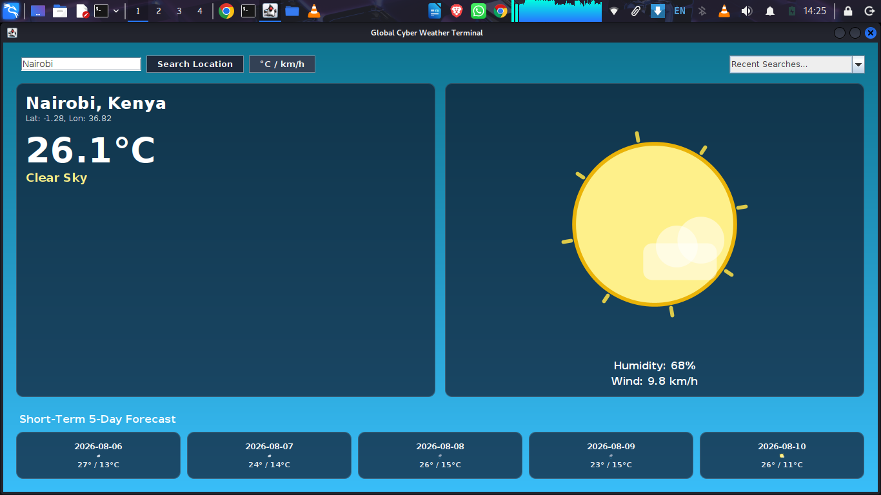

Figure 5.2: Rainy / Stormy Automated Interface State
Caption: Automated rendering of precipitation conditions (Sydney). Displays dark moody slate background, layered rain clouds with animated falling drops, and updated telemetry.
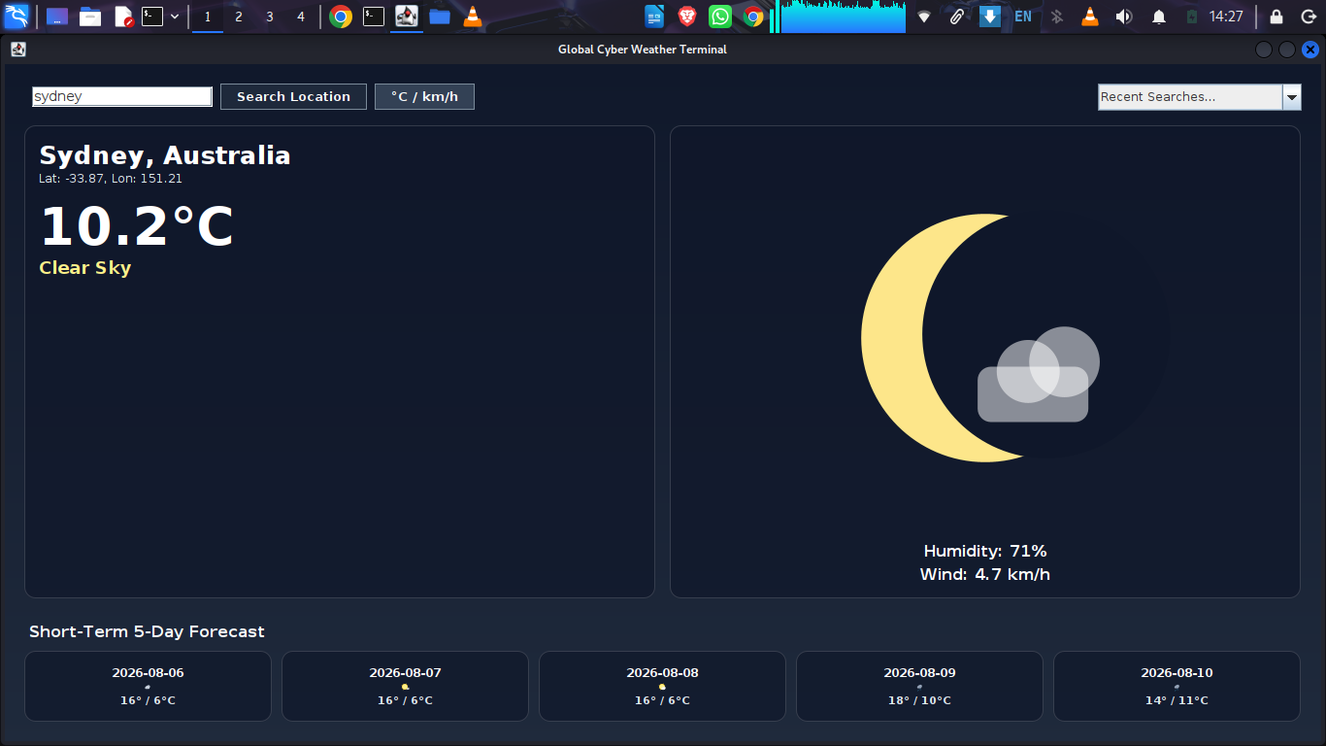

6.Error Handling & Exception Management
The Cyber Weather Information Terminal includes robust error handling to prevent application crashes and maintain a smooth user experience when dealing with network failures or invalid user inputs.

Key Mechanics
- Asynchronous Thread Isolation: All network requests execute inside a background SwingWorker thread. If an error occurs during fetching or parsing, the exception is caught off the main thread, keeping the GUI responsive and interactive.
- Input Validation & Feedback: When a user enters an unrecognized or misspelled location (e.g., searching for "nairobey"), the API parsing logic throws an IllegalArgumentException.
- User Dialog Alerts: Exceptions generated during the background fetch phase trigger a modal JOptionPane error dialog on the Event Dispatch Thread (EDT), alerting the user with a descriptive error message without resetting or corrupting the existing UI state.
- Graceful State Retention: If an invalid query fails, the application retains the previously rendered weather telemetry (e.g., keeping the existing background, temp metrics, and 5-day forecast intact) while re-enabling control inputs so the user can quickly retry.
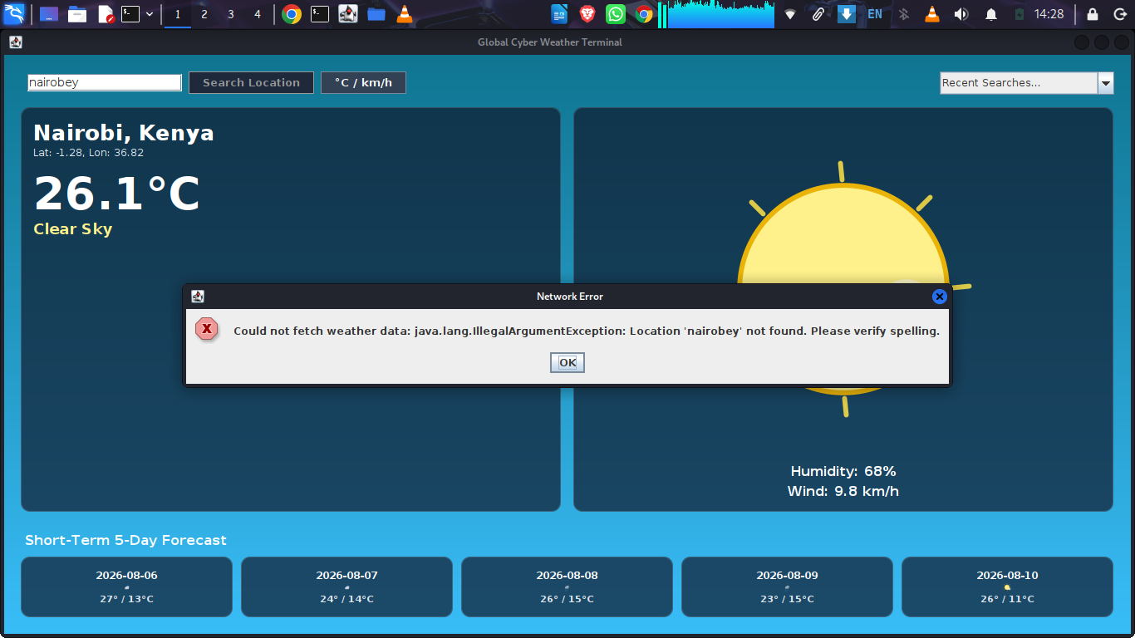

7. Compilation & Deployment Guide

Prerequisites
- Java Development Kit (JDK): Version 11 or higher.
- Operating System: Linux (Kali Linux / Ubuntu / Debian), macOS, or Windows.

Compilation Steps
- Open your terminal in the project root directory.
- Compile all source files into the target output directory (bin):

Bash
javac -d bin src/*.java

Execution Steps
Run the application specifying the classpath:

Bash
java -cp bin src.WeatherAppGUI

